

Full Management Services

Alpha Dimension Properties, Inc.
P.O. Box 33482
Northglenn, CO 80233

Office: (303) 475-5500

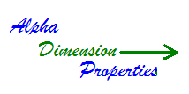

About Alpha Dimension Properties, INC.
About Alpha Dimension Properties, INC.

Alpha Dimension Properties, LLC started in 2002 by people
with years of experience in residential, apartment and
condo real estate. With a goal to improve the
quality of service and life for Investors,
owners, tenants and employees.

We take care of our customers!

Our Mission
Our Mission

Provide a comprehensive array of services
meeting and exceeding the needs of our customers.
Provide superior and memorable service through
communication and education that is next to none
other at all times. Every life we touch is considered
a client that we want to help improve their ability to
achieve happiness and harmony through timely,
honest and sincere handling and education.

DESCRIPTION OF SERVICES

- Collect Applications, process credit, background and employment check. Fee paid by applicant directly to Alpha Dimension Properties, LLC.
- Obtain Lease from qualified applicant
- Collect and escrow a deposit and lease fee agreed upon by the property owner.
- Maintain property bank account, send monthly statements to property owner by providing a secured web page for each property and send bank account overage no later than the 15th of each month to the property owner:
- Monthly Drive-by inspections to determine status of acceptance or condition of property.
- Securing and re-keying of property when needed.
- Portfolio transfer
- Obtain itemized repair bids from contractors
- Schedule and supervise any necessary repairs, cleanup and maintenance of the property
- Monthly status reports and evaluation, including recommendations on any repairs or maintenance to properly market the property.
- Constant monitoring and supervision of the property.
- Thorough and complete marketing evaluation to ensure proper monthly rental fee.
- Computer tracking of all property data to ensure effective management.
- Full County Court eviction process, owner will only pay filing fees and process serving fees up to and including garnishment of tenant’s wages.

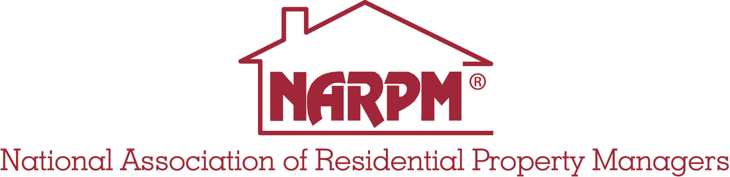

THINGS THAT SET US APART FROM OTHER MANAGEMENT COMPANIES:

- We keep a video library of every home, move in and out.
- Employee fidelity bond
- We carry O&E Insurance and Liability Insurance
- Separate escrow accounts for each property with weekly reconciling.
- Flat rate, no guess work
- Every one is our client from the investors, owners, tenants and employees.

WE STAY ON THE CUTTING EDGE OF TECHNOLOGY, PRODUCTS, LAWS AND ADVANCEMENTS:

- We are licensed and certified.
- We are members of the NARPM (National Association of Residential Property Managers) and the Regional Chapter of NARPM.
- We use the cutting edge of computer technology with a secured web site with logins for property managers, owners and tenants.
- Continuous and effective training required for all contractors and employees.
- Vendor Management insuring the most capable, price competitive and liable vendors are used.



*This brochure is for informational purposes only and does not guarantee rates until an agreement is reached and signed with Alpha Dimension Properties, LLC, rates are subject to change depending on time and circumstances.

Alpha Dimension Properties, Inc.
P.O. Box 33482
Northglenn, CO 80233

Office: (303) 475-5500

